*Assignment*

*Installation and Maintenance of Hardware and Its Components*

*Section 1: Multiple Choice*

1. *Which of the following precautions should be taken before working on computer hardware?*

*Ans:*

1. *What is the purpose of thermal paste during CPU installation?*

*Ans:* *To prevent the CPU from overheating.*

*3. Which tool is used to measure the output voltage of a power supply*

*unit (PSU)?*

*Ans:* *Multimeter*

*4. Which component is responsible for storing BIOS settings, such as date and time, even when the computer is powered off?*

*Ans: CMOS battery*

*Section 2: True or False*

*5. When installing a new hard drive, it is essential to format it before use.*

*Ans: True*

*6. A POST (Power-On Self-Test) error indicates a problem with the CPU.*

*Ans: True*

*7. It is safe to remove a USB flash drive from a computer without ejecting it first.*

*Ans: True*

*Section 3: Short Answer*

*8. Describe the steps involved in installing a new graphics card in a*

*desktop computer.*

*Ans:1.You need to check before you buy a new graphic card is it suitable with your pc’s motherboard power supply and case*

*2.Remove old graphic card and install the new one in that place*

*3.install the drives and test your graphic card*

*9. What is RAID, and what are some common RAID configurations?*

*Ans:* *RAID (Redundant Array of Independent Disks) is like having backup copies of your important files in your computer*

*RAID-1 (Stripping)*

*RAID-2 (Mirroring)*

*RAID-3 (Bit-level stripping with dedicated parity)*

*RAID-4 (Block-level stripping with dedicated parity)*

*RAID-5 (block-level stripping with distributed parity)*

*RAID-6 (block-level stripping with two parity bits)*

*Section 4: Practical Application*

*10. Demonstrate how to replace a CPU fan in a desktop computer.*

*Ans:* *1. The first step is to find the CPU fan and its model.*

*2. Then turn it off and unplug the computer.*

*3. Now to open it and find the fan*

*4. Removing the fan to clean the processor.*

*5. Then a new fan is installed and a thermal paste is applied.*

*6. Now it is closed and the fast is tested*

*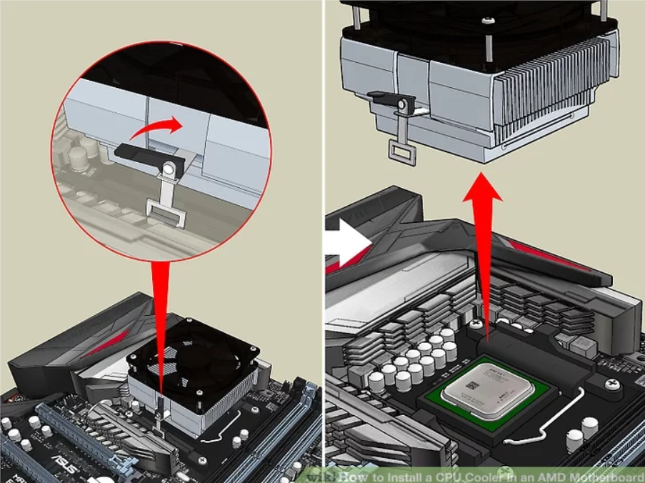*

*Section 5: Essay*

*11. Discuss the importance of regular maintenance for computer hardware and provide examples of maintenance tasks.*

*Ans:* *Regular Maintenance of computer hardware is very important for to receive the best performance, reliability and for long life span. Reasons for need of regular maintenance are given below: -*

*1. Best performance: Cleaning the hardware is necessary to avoid unnecessary problems and improves performance.*

*2. Long lifespan: With proper maintenance the lifespan of the components remains long.*

*3. Preventative maintenance: By cleaning it regularly it helps to identify any problems before it becomes big issue.*

*4.Cost efficiency: If proper maintenance is done then the failure of components will be less and it reduces cost also.*

*5. Ensure reliability: Due to regular maintenance it helps to make sure hardware operates properly.*

*Examples of computer hardware maintenance tasks:*

*Cleaning - Regular cleaning of dust from fans, heat sinks and cases will help to avoid overheating and improves airflow in it.*

*Hard drive maintenance: Hard drive maintenance is also needed, means to cleanup the disk to remove temporary files and unnecessary data.*

*Monitoring temperature: To prevent overheating it's necessary to monitor CPU & GPU temperatures.*

*Checking and updating drivers: To make sure that the device drivers are updated on time to resolve problems and improve its performance.*

*Updating firmware: to improve stability it is needed too keep firmware on components like motherboard, GPU and SSD.*

*Battery maintenance: Maintenance of batteries is also important to preserve their capacity and lifespan.*

*Backup management: in case of hardware failure to make sure recovery of data regular backing up of important data is necessary.*